C192963 Test and user acceptance documentation

Test plan (What, where, how to test or reference to a script in at test plan (mainly projects)):
TEST SYSTEM(s): ___Q93____

Code resides under ICF node /default_host/sap/bc/recource with handlerclass: ZCL_CAWEB_RESTFUL_CONTROLLER, and is accessed through browser using url: system + /resources/timewriting/
With no entries in the mappingtable no result will be returned.

The packet includes a maintenance view with transaction code:
ZCAWEB_RESOURCE

The code do not interfere with any other sap code / modules.
The code is totally standalone and do not touch / modify any older functionality.

Enter the url (system + /resources/timewriting/{user}/{date}) into a browser.

- Enter userid and password for the system and click Ok.

Expected result (Description):
- Provided the login information is correct the JSON data is displayed in the browserwindow, if not an error message is displayed.

Test result (Documentation and proof of result by screen shot – use ALT+PrintScreen):
- Browserwindow result:

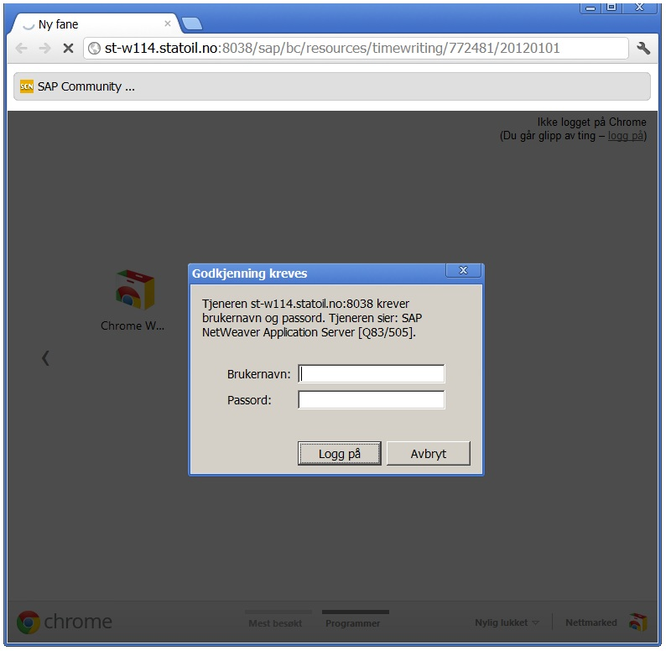

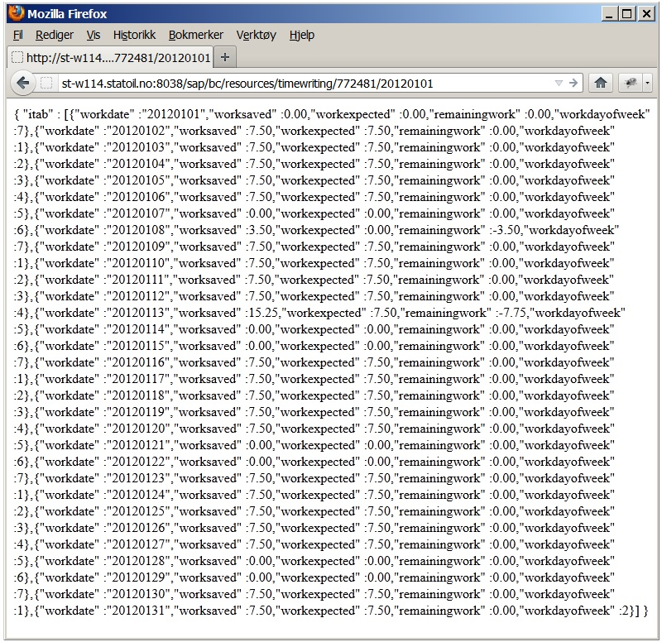

Approval from user (Insert mail confirmation - use ALT+PrintScreen):
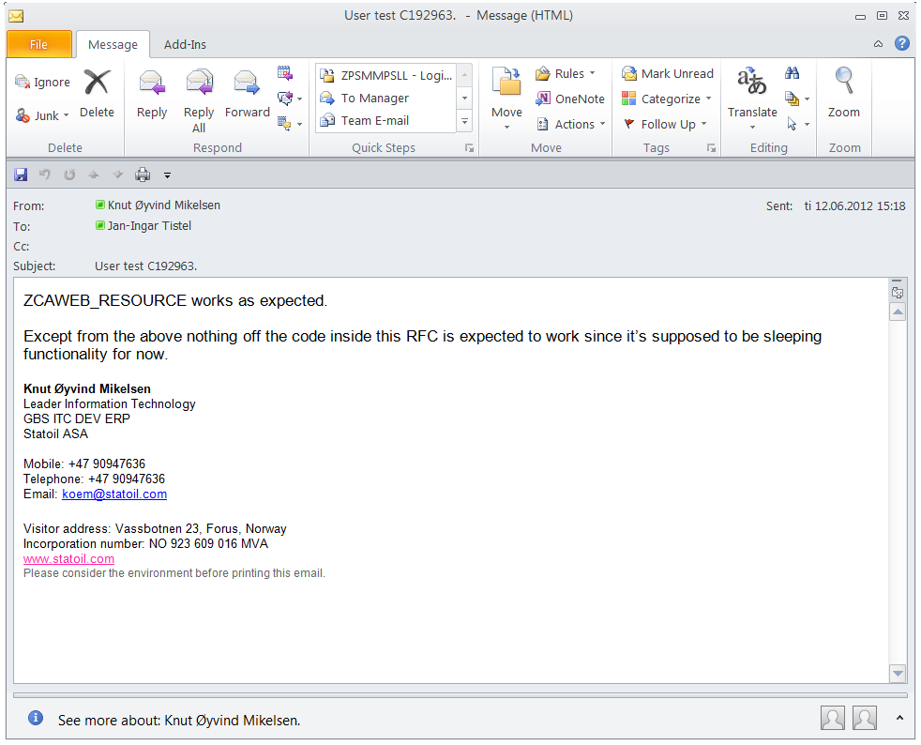

Approval from solution architect (Insert mail confirmation - use ALT+PrintScreen):

Link(s) or reference (Test scripts, test execution log etc.):

Document is to be added in RFC under “Attachments” as inserted file.

Documentation to ensure quality according to SOX key control KC0203 and KC0204 before changes are moved to a production system.

